The scoring of this lab exam is 1,2 points

Important information
Download LabExam1_eng.circ from Moodle and rename it as A_surname_name.circ. For example, A_martinez_pedro.circ. After finishing the lab exam, the student must submit to Moodle the file A_surname_name.circ including the responses of the exam.
Don’t use switches for constant signals, instead use Logisim constants 0 and 1 (in Wiring).
Use binary inputs. Don’t use bit-vectors as inputs.
Remember that all circuits must be ready for simulation, otherwise the score of the circuit will be zero points.

Lab exercise
Particular functions F(A,B,C) and G(A,B,C,D) have been assigned to each student according the ID number in the file Funciones_F_G.pdf. In the first column of Funciones_F_G.pdf the student can identify the row corresponding to his/her ID. The rest of the columns on the right contain, respectively, the positions of the truth table in which F takes value 1 and in which G takes value 1. This search can be easily done by typing < Ctrl + f >.

Part 1 (40%). Function F
Open your A_surname_name.circ. First of all, type in the upper part of the main panel the following data (select the icon 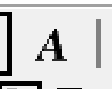 , go to the equal sign (=), click aside and type the requested information, as can be seen in the figure below).
- The assigned positions in which function F takes value 1 (according to your ID).
- ID number:

Then, answer the following questions by typing aside the respective equal signs:
- Simplified expression of F as SOP. Use the tilde as an inverter. (5%)
- Simplified expression of F as POS. Use the tilde as an inverter. (5%)

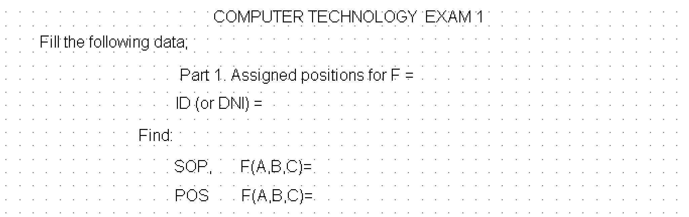

Finally, design the following subcircuits (we have already defined them for you, so enter into the subcircuit and put your solution):

- (subcircuit 1.1.). Circuit of F using NOR gates in two levels. You can use some inverters if necessary. (15%)
- (subcircuit 1.2.). Design an active-low output DEC 3x8 with active-high enable, using modules DEC 2x4 of the Logisim library. (15%). Important remark: put the property Disabled Output of the decoders DEC 2x4 to Zero.

Part 2 (40%). Function G
First of all, type the assigned positions in which function G takes value 1 (according to your ID).

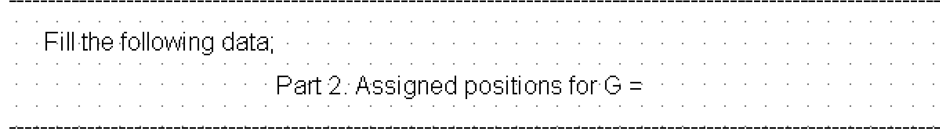

Design the following subcircuits (we have already defined them for you, so enter into the subcircuit and put your solution):
- (subcircuit 2.1). Digital circuit of G using the module DEC3x8 of subcircuit 1.2. You can use one o more modules and the necessary gates.(20%)
- (subcircuit 2.2). Digital circuit of G using only one MUX8x1 and the necessary inverters. Take the selection inputs freely.(20%)

Part 3 (20%). Main:
- (main) Design the main circuit that integrate the aforementioned subcircuits 1.1, 2.1 and 2.2 with common inputs A, B, C for F and A, B, C, D for G. (20%)

